Alison Nardini

CI 403 – Poetzel

Capstone Project

November 3, 11

Introducing Slope

**Unit Introduction/Rationale**

*Overview*

The content that will be covered in these three days will be introducing slope, finding the slope from a graph, from two points, and graphing slope intercept form. I chose this concept because I got to plan a lesson as well as observe the introduction of slope progression. I was able to observe some common misconceptions that I would not have initiated on my own. I observed difficulties from creating the right triangle to calculate rise/run or choosing two points on a line.

I have built in time for students to work in class so I can help some students individually and in small groups. I believe calculating slope is something that comes better with practice rather than lecture. The technology I have incorporated into my lesson is a projector and an ELMO. For the motivation and initial introduction of slope, I will be showing a video that puts the slope of a line into context using mountains, stairs, hills, and more. I will also be using the ELMO to demonstrate the first one or two problems on each assignment for the class. I am doing this to help the students get started on their assignment.

*Objective/Purpose*

The purpose of this lesson is to primarily introduce the concept of slope to the students. They have background knowledge of graphing equations from a table of values, but not straight from an equation. The main ideas of the unit are for students to compare and contrast different lines, namely the steepness. From there, they will learn the different ways to calculate slope as well as find the equation of a line.

After this unit, the students will be able to calculate the slope of a line given two points, calculate the slope of a line with no given points, calculate the slope from ordered pairs, graph a line from slope-intercept form, re-write linear equations to be in standard form, slope-intercept form, or point-slope form. Students will also be asked various contextual problems so they can connect what they are learning about slope and linear equations to ‘real-life’ problems.

*Meeting the Needs of My Students*

Having 4 ELL students does change how I will construct my lessons. Since there is some vocabulary such as slope, rise, run, positive, negative, zero, undefined, etc. that these students must understand in order to understand the concept, I must be sure that these students know the vocabulary. Having a Spanish speaking aid will be incredibly helpful especially during the individual work time. At this point, she can explain terms and concepts in more detail. In the video and in the notes I provide the word I am defining in Spanish since there are 4 students who will benefit from that.

Since I have two students with IEPs due to reading proficiency, I plan to keep my examples mostly visual. There will not be much reading in the examples or in the notes. This should help these students keep up with the lesson. Keeping the notes short will allow for more students to be engaged in the activity. The longer the notes, the less engaged students are with the material. I have created note sheets to benefit all of the students in my class. It will outline the main points of the lesson as well as keep their notes organized and readable. I believe that the note sheets will not only help the students with IEPs and the ELL students, but each student in the classroom.

**Formal Lesson Plan Sequence**

*Day 1*

*Name:* Alison Nardini

*Date:* 11/3/11

*Grade Level:* 8th

*Course:* Algebra 1

*Time Allotted:* 50 Minutes

*Number of Students:* 20

1. Goal(s):
   1. Common Core Mathematics Standards:
      1. 8.EE: Understanding the connections between proportional relationships, lines, and linear equations.
         1. Graph proportional relationships, interpreting the unit rate as the slope of the graph. Compare two different proportional relationships represented in different ways. *For example, compare a distance-time graph to a distance-time equation to determine which of two moving objects has greater speed.*
         2. Derive the equation *y* = *mx* for a line through the origin and the equation *y* = *mx* + *b* for a line intercepting the vertical axis at *b.*
   2. Common Core Standards for Mathematical Practice:
      1. Model with mathematics
         1. They are able to identify important quantities in a practical situation and map their relationships using such tools as diagrams, two-way tables, graphs, flowcharts and formulas. They can analyze those relationships mathematically to draw conclusions.
2. Objective(s):
   1. Students can recall the two definitions of slope: Rise/run and y2-y1/x2-x1
   2. Given the graph of a line, Students can classify the line as having a positive slope, negative slope, zero slope, or undefined slope.
   3. Given the graph of a line, Students can calculate the slope.
   4. Given the ordered pairs of two points on a line, students can calculate the slope.
3. Materials and Resources
   1. Note Sheet
   2. Pencil
   3. Worksheet/Homework
   4. Projector
   5. Document Camera
4. Motivation
   1. Show video that gives a real-life context to slope.
      1. <http://prezi.com/zf8wis33bsnw/test/>
      2. Have a class discussion about how we can describe the steepness of mountains, hills, stairs, and relate it back to lines.
      3. Talk about uphill vs. downhill lines.
5. Lesson Procedure
   1. Warm Up (6 minutes)
      1. One problem: Graph from a table of values.
   2. Show Video and have class discussion as mentioned above under “motivation”(6 minutes)
      1. Have students fill in as much as they can on their note sheets
      2. Positive, Negative, Zero, Undefined. Have the students fill in the note sheet with the terms next to the graphs.
   3. Define Slope (5 minutes)
      1. Rise/Run
         1. What is rise?
            1. Up and down in the y direction
            2. Count the rise first before you count the run to avoid missing negative signs.
         2. What is run?
            1. Left and right in the x direction.
      2. Change in Y/Change in X
         1. Change in Y is the Rise
         2. Change is X is the Run.
         3. Can be calculated given a line or given two points with out a graph.
      3. Explain that you can find the slope of a line given a graph or two points on the line.
      4. Explain that the slope is the rate of change of the line.
         1. The rate of change tells, on average, how a quantity is changing over time.
   4. Examples (10-15 minutes)
      1. Rise/Run given a graph.
         1. How to find two points on the line.
            1. Points must be on the line
            2. Best if you choose whole numbers (i.e. On the corner of the grids) to avoid estimation.
         2. Explain how to make the right triangle.
      2. Example given two points on a line.
   5. Go through number 11 on the worksheet as a class. (5 minutes)
   6. Time to work on worksheet.
6. Closure
   1. Have students fill in the “summary” section in their notes
      1. Redefine Slope as Rise/Run
      2. Talk about how to choose points on a line
      3. Explain that a good way to check if your slope is correct is to look at the direction the line is going.
7. Anticipated Student Responses
   1. Not making right triangles to calculate rise/run
      1. It’s important to make a right triangle so we know exactly how much we are running and how much we are rising. If we make a random triangle, we can’t easily count the grid lines. The lines must go strait up or down from the first point and straight to the second point.
   2. Having trouble choosing points on a line
      1. Remember that the grid lines represent a whole number. They go 1, 2, 3, and so on. Each line is one unit, so it’s best if we put our points at the ‘corners’.
      2. Draw a picture. Explain that if you zoom into the grid, you get a cross where two whole number points meet. These are the best places to put our points so we don’t have to estimate.
      3. Ask the class what the ordered pair would be for a floating point. Show them that having a whole number is better.
   3. Mixing up rise and run.
      1. Rise is up and down. Run is left and right.
   4. Missing the negative sign when there should be a negative slope.
      1. Explain that if you have to go up to reach the other point, the rise is positive. If you have to go down to reach the other point, the rise is negative.

**Notes Monday November 7, 2011**

Name: ____________________________________________

Warm Up

Graph the following equation by using a table of values.

Y = -1/2 x + 1

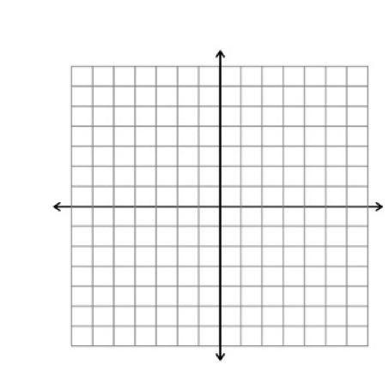

|  |  |
| --- | --- |
| X | Y |
| -5 |  |
| -3 |  |
| -1 |  |
| 0 |  |
| 1 |  |
| 5 |  |

Notes

What I saw in the video:

______________ Negative ________________ Undefined

 Uphill Downhill Horizontal Vertical

Slope =

Rise:

Run :

Rate of Change:

**Find the slope of the line. Find the slope of the line**

**through the two given points.**



 (0,5) (-3,-1)



The graph to the right shows the amount spent on food and drink at U.S. restaurants in recent years.

Find the rate of change for 1908-1990 and 1990-2000.

Summary

Finding Slope Name:_________________________________

**Find the slope of the line through each pair of points.** Period:________

1. (-4,7),(-6,-4) 2. (17,-13),(17,8) 3.(3,0),(-11,-15)

4. (1,-4),(-2,-1) 5. (12,2),(-7,5) 6. (0,4),(5,9)

**Find the slope of each line.**

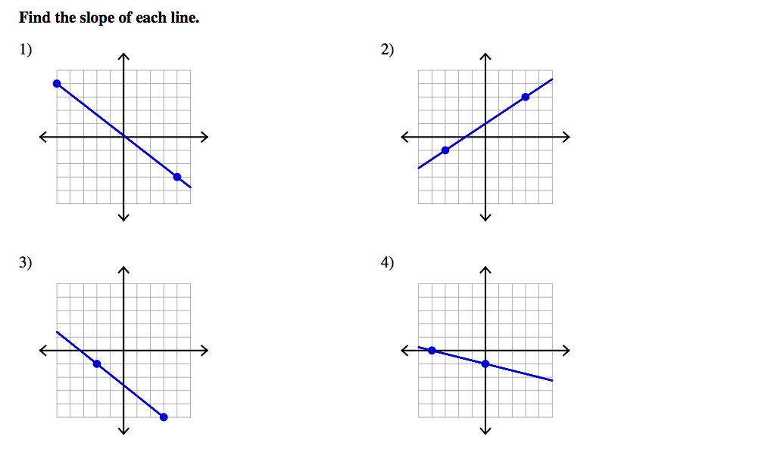

7.

10.

9.

8.

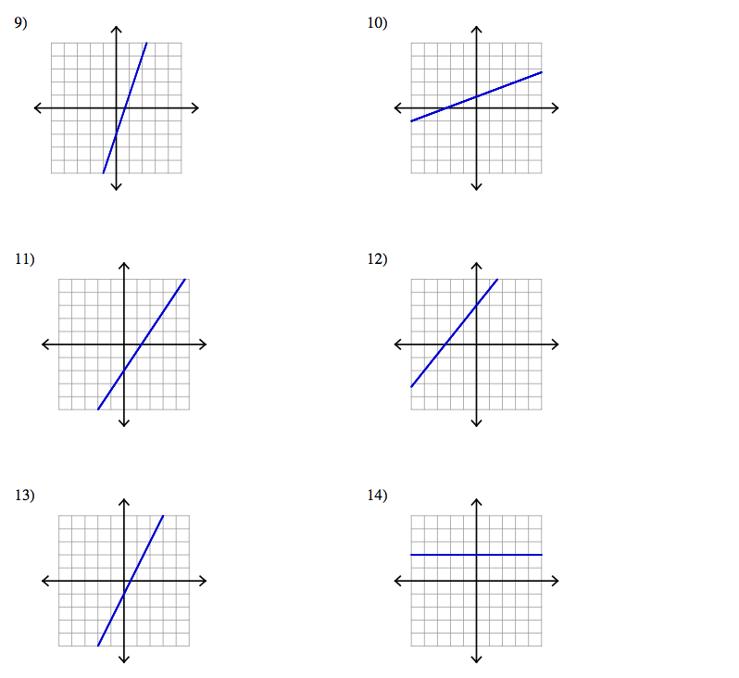

16.

15.

14.

13.

12.

11.

17) Find the slope of a line that passes through the origin and point (r,-s).

Finding Slope Name:____________KEY________________

**Find the slope of the line through each pair of points.** Period:________

1. (-4,7),(-6,-4) 2. (17,-13),(17,8) 3.(3,0),(-11,-15)

3/2 -5 -15/8

4. (1,-19),(-2,-1) 5. (12,2),(-7,5) 6. (0,4),(5,9)

-3 1/7 1

7. -7/9 8. 2/3 9. -4/5 10. -1/4

11. 3 12. 3/8 13. 3/2 14. 5/4

15. -2/3 16. 0

17) r/-s

*Day 2*

*Name:* Alison Nardini

*Date:* 11/3/11

*Grade Level:* 9th

*Course:* Algebra 1

*Time Allotted:* 50 Minutes

*Number of Students:* 26

1. Goal(s):
   1. Common Core Mathematics Standards:
      1. 8.EE: Understanding the connections between proportional relationships, lines, and linear equations.
         1. Graph proportional relationships, interpreting the unit rate as the slope of the graph. Compare two different proportional relationships represented in different ways. *For example, compare a distance-time graph to a distance-time equation to determine which of two moving objects has greater speed.*
         2. Derive the equation *y* = *mx* for a line through the origin and the equation *y* = *mx* + *b* for a line intercepting the vertical axis at *b.*
   2. Common Core Standards for Mathematical Practice:
      1. Model with mathematics
         1. They are able to identify important quantities in a practical situation and map their relationships using such tools as diagrams, two-way tables, graphs, flowcharts and formulas. They can analyze those relationships mathematically to draw conclusions.
2. Objective(s):
   1. Given a linear equation, students can identify the slope and the y-intercept.
   2. Given a linear equation, students can sketch the graph of the line.
   3. Given a linear equation, students can re-write it in slope-intercept form.
3. Materials and Resources
   1. Note Sheet
   2. Worksheet
   3. Document Camera
   4. Projector
4. Lesson Procedure
   1. Warm Up
      1. Review from yesterday. Find the slope.
         1. (3,9)(12,-2)
         2. y=-1/2x + 3
   2. Define Slope intercept form
      1. Y=mx+b
         1. Slope*X
         2. Y-intercept is the number that stands alone. Where the graph crosses the y-axis.
      2. Y = mx
         1. Equation of a line through the origin
   3. Two examples
      1. Y=2/5x+2
         1. Plot the y-intercept
         2. Using the slope, plot two more points on the line.
            1. You might have to go in the ‘backwards’ direction.
            2. Instead of +/+ 🡪-/- or +/-🡪-/+
         3. Connect points to create line.
      2. 3x + 2y = 0
         1. Write equation in slope-intercept form.
         2. Plot the y-intercept
            1. If there is no number standing a lone, we can add 0 to any equation without changing it. The line goes through the origin.
            2. Y=mx
         3. Using the slope, plot two more points on the line.
         4. Connect points to create line.
   4. Worksheet
5. Closure
   1. On Note sheet: Summary of the lesson:
      1. Slope intercept form.
         1. How find slope in a linear equation.
         2. How to find Y-intercept in a linear equation.
      2. Steps to graphing the line when you are given a linear equation.
         1. Solve for y.
         2. Plot y-intercept.
         3. Plot two more points using the slope.
         4. Connect the points to create the line.
6. Anticipated Student Responses
   1. Having trouble identifying the slope and the y-intercept from the equation.
      1. The slope is always the number multiplied by x.
      2. The y intercept is the integer that always stands alone.
   2. Plotting the y-intercept on the x-axis.
      1. Remember that the y-intercept is where the line crosses the y-axis. The y-axis is the one that goes up and down.
   3. Forgetting the negatives when plotting points using the slope.
      1. Remember that if we have a negative, we are either going down or to the left.
      2. The positive directions are up and to the right.
   4. Not putting their equation into slope-intercept form before trying to identify the slope and y-intercept.
      1. Remind students that they must solve for y, or get y all by itself, before you can graph the equation.

**Notes Tuesday November 8, 2011**

Name: ____________________________________________

Warm Up

**Find the slope**

1. (-9,12),(3,18) 2)

Notes

Slope-Intercept Form:



Examples:

Write the following equations in slope-intercept form.

**Graph the equation**

 

**Write and equation given one point and the slope**

1. Slope intercept Form
2. Replace m with the slope, y with the y-coordinate, and x with the x-coordinate.
3. Solve for b.
4. Re-write equation in slope-intercept form.

Write an equation of a line that passes through (1,5) with slope 2.

**Write an equation given two points.**

1. Find slope.
2. Slope intercept form.
3. Plug in the values that you know.
4. Solve for b.
5. Re-write equation in slope-intercept form.

Find the slope of the line containing the points (-3,-1) and (6,-4).

Slope-Intercept Form Name:_________________________________

**Find the slope and y-intercept of each equation.** Period:________

1.  2.  3. 

4.  5.  6. 

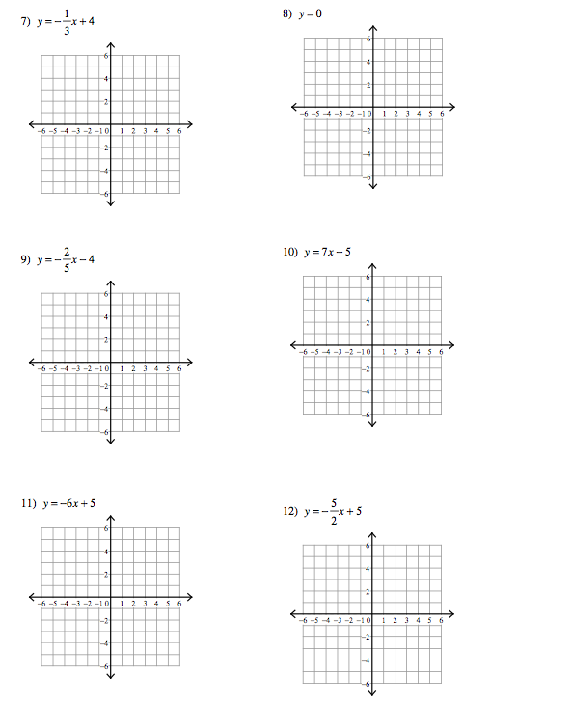**Graph the following equations.**

13) Write the equation of a line with slope = 4 and y-intercept = -2.

14) Suppose you have already saved $50 toward the cost of a new TV. You plan to save $5 more each week for the next several weeks.

a) Write an equation for the total amount T you will have in w weeks.

b) Graph the equation



c) Find the total amount saved after 7 weeks.

Slope-Intercept Form Name:___________KEY_________________

**Find the slope and y-intercept of each equation.** Period:________

1.  2.  3. 

slope: -5/2, y-int: -5 slope: -1, y-int: 3 slope: 1/2, y-int:-1/2

4.  5.  6. 

slope: 8/3, y-int: 3 slope: -1/5, y-int:-3 slope: 0, y-int: 5

**Graph the following equations.**

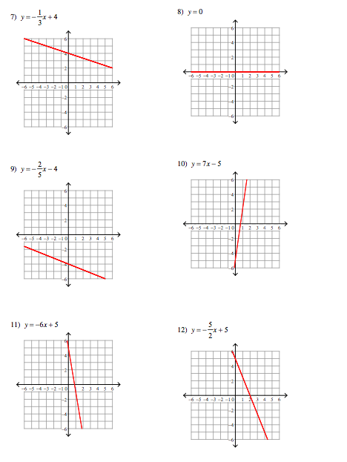

13) Write the equation of a line with slope = 4 and y-intercept = -2.

Y=4x-2

14) Suppose you have already saved $50 toward the cost of a new TV. You plan to save $5 more each week for the next several weeks.

a) Write an equation for the total amount T you will have in w weeks.

Y=5x+50

b) Graph the equation



c) Find the total amount saved after 7 weeks.

$85

*Day 3*

*Name:* Alison Nardini

*Date:* 11/3/11

*Grade Level:* 9th

*Course:* Algebra 1

*Time Allotted:* 50 Minutes

*Number of Students:* 20

1. Goal(s):
   1. Common Core Mathematics Standards:
      1. 8.EE: Understanding the connections between proportional relationships, lines, and linear equations.
         1. Graph proportional relationships, interpreting the unit rate as the slope of the graph. Compare two different proportional relationships represented in different ways. *For example, compare a distance-time graph to a distance-time equation to determine which of two moving objects has greater speed.*
         2. Derive the equation *y* = *mx* for a line through the origin and the equation *y* = *mx* + *b* for a line intercepting the vertical axis at *b.*
   2. Common Core Standards for Mathematical Practice:
      1. Model with mathematics
         1. They are able to identify important quantities in a practical situation and map their relationships using such tools as diagrams, two-way tables, graphs, flowcharts and formulas. They can analyze those relationships mathematically to draw conclusions.
2. Objective(s):
   1. Given the slope of a line and a point on a line, students can write the equation of that line in point-slope form.
   2. Students can apply what they have learned in the past 3 lessons to the contextual problems on their worksheet.
   3. Given an equation, the student can re-write it in standard form, slope-intercept form, and point-slope form.
3. Materials and Resources
   1. Note Sheet
   2. Work Sheet
   3. Projector
   4. Document Camera
4. Lesson Procedure
   1. Warm Up
      1. Graph 2 equations:
         1. 4x+2y=1
         2. y=-1
   2. Point-Slope Form
      1. 
      2. Need one point on the line and the slope to write the equation in point-slope form.
   3. Example 1 on how to write an equation in point slope form.
   4. Have the students do example 2 on their own.
      1. Walk around to see if students are on the right track. This one is tricky so you may need to give them some tips.
         1. What is the slope of a horizontal line?
         2. What doe we know about the rise? Run?
   5. Go through the next example together.
   6. Give students sometime to communicate with each other and come up with and answer for the last example problem. Have a class discussion on this topic.
   7. Have students work on worksheet.
5. Closure
   1. Fill in summary as a class.
      1. Point slope form: need the slope and a point on a line.
      2. Standard Form: ax + by = c.
      3. Can re-write any equation to be in each of these forms.
   2. Review/work Day tomorrow to finish the worksheets from the past 3 days and ask questions to prepare for the quiz on Friday.
6. Anticipated Student Responses
   1. Students struggling to solve for the correct variable.
      1. Remind students of what they know. Ask them what their given information they have? What are they looking for? What should their answer look like?
   2. Lack of motivation to complete the last problems on the review.
      1. These are going to make the students think. Depending on how the class is doing, you can review them as a class tomorrow.

**Notes Wednesday November 9, 2011**

Name: ____________________________________________

Warm Up

**Graph the equation.**



Notes

Point Slope Form:

Standard Form:

Examples:

1) Write the equation of a line that passes through point (-1,5) with slope -3.

2) Write the equation of a horizontal line that passes through (6,-2)

3) Write the following equation in standard form. .

4) Can vertical lines be written in point-slope form? Slope-intercept form? Why? Why not?

Summary

Point-Slope Form Name:_________________________________

+ Review Period:________

**Write the point-slope form of an equation for a line that passes through each point with the given slope.**

1. (3,8), *m*= 2 2. (-4,-3), *m*=1 3. (-2,4), *m*=-3

4. (8,-3), *m*=  5. (-6,3), *m*= - 

**Write each equation in standard form.**

6. y-13 = 4(x-2) 7. y-1=-5(x+1) 8. y-6 = 1.3(x+7)

**Write the following equations in point-slope form, slope-intercept form, and standard form. Then graph the slope-intercept equation.**

9. The line that passes through (5,-3) with slope 10.

10. The line that passes through (0,-6) with slope 

**Find the Slope**

11. (1,1), (4,4) 12. (-6,0),(2,3)

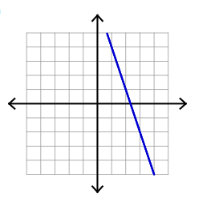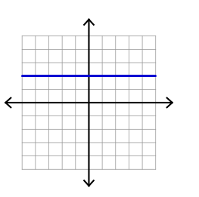13. 14.

**Find the slope and y-intercept.**

15.  16. 

17. In the middle of the 1998 baseball season, Mark McGwire seemed to be on track to break the record for most runs batted in (RBIs). After 40 games, McGwire had 45 runs batted in. After 86 games, he had 87 runs batted in. Write a linear equation to estimate the number of runs batted in for any number of games that season.

18. How is the y-intercept related to a flat fee?

Include the following in your answer:

* The point at which the graph would cross the y-axis if your cellular phone service provider charges a rate of $.07 per minute plus a flat fee of $5.99.
* And a description of a situation in which the y-intercept of its graph is $25.

Point-Slope Form Name:_________KEY___________________

+ Review Period:________

**Write the point-slope form of an equation for a line that passes through each point with the given slope.**

1. (3,8), *m*= 2 2. (-4,-3), *m*=1 3. (-2,4), *m*=-3

y-8=2(x-3) y+3=x+4 y-4=-3(x+2)

4. (8,-3), *m*=  5. (-6,3), *m*= - 

y+3=3/4(x-8) y-3=-2/3(x+6)

**Write each equation in standard form.**

6. y-13 = 4(x-2) 7. y-1=-5(x+1) 8. y-6 = 1.3(x+7)

y-4x=5 y+5x=4 y-1.3x=15.1

**Write the following equations in point-slope form, slope-intercept form, and standard form.**

9. The line that passes through (5,-3) with slope 10.

Y+3=10(x-5), y=10x-47, y-10x=-47

10. The line that passes through (0,-6) with slope 

y+6=3/4(x), y=3/4x – 6, y – 3/4x=-6

**Find the Slope**

11. (1,1), (4,4) 12. (-6,0),(2,3)

1 3/8

13. 0 14.-3

**Find the slope and y-intercept.**

15.  16. 

slope: 2, yint:8 slope: -2/3, y-int: 1

17. In the middle of the 1998 baseball season, Mark McGwire seemed to be on track to break the record for most runs batted in (RBIs). After 40 games, McGwire had 45 runs batted in. After 86 games, he had 87 runs batted in. Write a linear equation to estimate the number of runs batted in for any number of games that season.

87-45/86-40 = 11/13

18. How is the y-intercept related to a flat fee?

Include the following in your answer:

* The point at which the graph would cross the y-axis if your cellular phone service provider charges a rate of $.07 per minute plus a flat fee of $5.99.
* And a description of a situation in which the y-intercept of its graph is $25.
  + **The line will cross the y-axis at 5.99. eqn of line is y=.07x+5.99**
  + **You are always charged 5.99 even if you talk for 0 minutes.**
  + **If the y-int is 25, then you get an automatic charge of 25 if you talk for 0 minutes.**

**Assessment of Lessons/Unit**

Each of the worksheets will serve as informal assessment for me. The students will have class time to work on them not only after they have learned the material, but also the day before the quiz will be a ‘work day’ where students can complete these assignments and ask questions before the quiz. I decided to build in this workday because this material is important and when I had the opportunity to teach it, the students struggled and I hope that this extra time will give students the extra time they need to let the concepts sink in. These worksheets will be collected at the end of the class on Thursday and graded to hand back to them. They will be receiving feedback throughout the time they have to work on each of these worksheets so they know if they are on the right track.

On the Friday of that week, students will take a short quiz to measure what they have learned in these 3 days of lessons. This will be a formative assessment. I can grade these quizzes over the weekend and decide if I should move forward to the next section on Monday or if one more day needs to be spent on this material. I can also gain information on whether certain students do or do not understand the concepts. If the majority of the class seems to do poorly on the quiz, we will spend another day on the material. If there are only a few students who do poorly, I will seek those students out and work with them individually.

In addition to this quiz, there will be a chapter test at the end of this chapter. There will be another review assignment closer to the test day so the students can also have that extra practice before it is time to take the test.

**Quiz**

Name:________________________________

**Find the slope.**

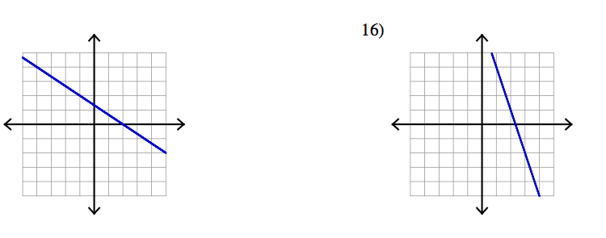

1.

2.

3. (-1,4),(5,8)

4. A ladder reaches a height of 16 feet on a wall. If the bottom of the ladder is placed 4 feet

away from the wall, what is the slope of the ladder as a positive number?

**Write the following equations in slope-intercept form and sketch the graph. Identify the slope and the y-intercept.**

5. 2x-6y=3 6. 4y=-x+2



**Write the equation of the line.**

7. The line that passes through point (3,3) with slope -.

8. The line that passes through (-6,-2) with slope 

9. Why is slope important in architecture?

Include the following in your answer:

* An explanation of how to find the slope of a roof, and
* A comparison of the appearance of rooms with different slopes.

**Quiz**

Name:________________________________

**Find the slope.**



1.

2.

-2/3 -3

3. (-1,4),(5,8)

2/3

4. A ladder reaches a height of 16 feet on a wall. If the bottom of the ladder is placed 4 feet

away from the wall, what is the slope of the ladder as a positive number?

4

**Write the following equations in slope-intercept form and sketch the graph. Identify the slope and the y-intercept.**

5. 2x-6y=3 y=1/3x-3 6. 4y=-x+2 y=-1/4x+1/2



**Write the equation of the line.**

7. The line that passes through point (3,3) with slope -.

y-3=-6/5(x-3)

8. The line that passes through (-6,-2) with slope 

y+2=2/3(x+6)

9. Why is slope important in architecture?

Include the following in your answer:

* An explanation of how to find the slope of a roof, and
* A comparison of the appearance of rooms with different slopes.
  + You measure from the edge to the middle and measure how far up the top of the roof is from the lower edge. (Make a right triangle)
  + Bigger slope = steeper roof.